OOP PROJECT CLASS DIAGRAM

NAME: HANZLA SIBGHAT

SEC: CS-B

ROLL: I190515

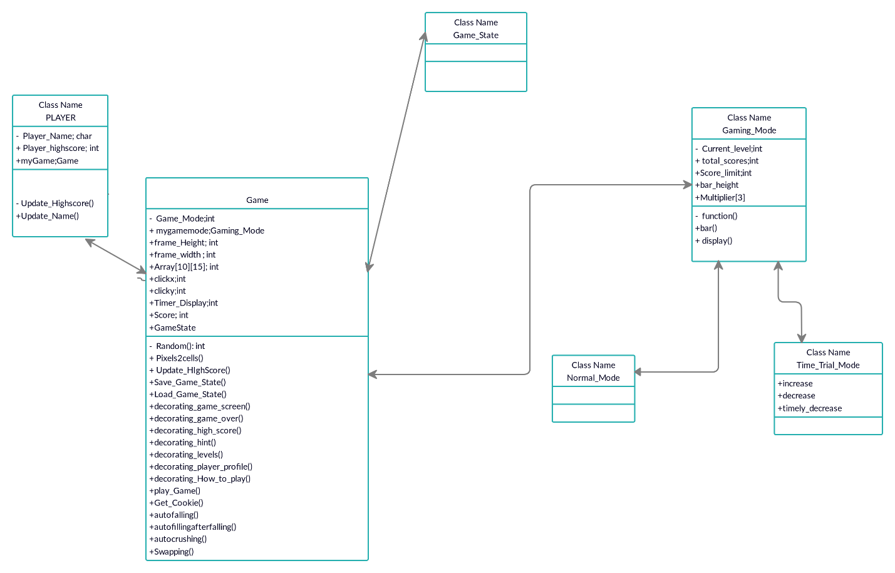

In this class diagram basically I have made 4 types of classes.

1. Player class
2. Game class
3. Game_State
4. Gaming_Mode

And there are two inherited classes which are inherited from Gaming_Mode class. Aggregation is happening between player class and game class and gaming mode and game class.

Player class has basically 3 public attributes name, high score and my game object and have 2 methods.

Game class have 10 attributes which are making aggregation with player class. And methods which are used to make and implement the game functionality and the other class of gaming mode which have 5 attributes and 3 methods which are used to display borders bars and decoration functionalities and 2 classes are inherited from this class which are basically modes of this game.

In the game class I have used pixels2cells() function which is used to make each grid size equal like all are in size of square because if I have not made this I have to make every cell shape function to move them but this function is generic to move a shape where ever we click in the cell. And getcookie() function is used to display randomly the 5 shapes which are used in this game.

Autocrushingfunction() is used to completely remove the gems which are automatically joined 3 or 4 or more in same place. Swapping() is used to swap the gems to change there place respectively.

Now in gaming_mode class levels, scores and bar height are calculated in displayed. The 2 inherited classes which are mods of the game trialmode() and the normalmode().

In trialmode() the bar run down faster and clock time decremented. If the bar runs down or clock time become zero the game will be over.

And in normalmode() the bar increses with points and when the bar fills the level increase there are 3 levels but the 4th level is infinity for playing it for long time and score multiply by double when each level passes and difficulty level increses.